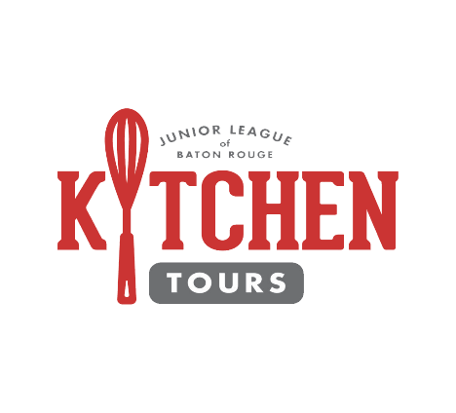



Dear Valued Sponsor,

The Junior League of Baton Rouge is excited to bring Kitchen Tours to our community for a sixth year on December 9, 2018. As we prepare for Kitchen Tours, we invite you to join us in advancing the League's Mission of promoting voluntarism, developing the potential of women and improving the community through the effective action and leadership of trained volunteers.

With the funds raised during Kitchen Tours, our members are able to continue to serve as catalysts for lasting community change in the areas of health, education, and cultural development.

Corporate sponsorship of Kitchen Tours provides a unique opportunity to market your services and products to an enthusiastic and engaged audience of over hundred plus guests. You can also support our cause without making a monetary gift, through the donation of quality items such as:

* Items to make the VIP brunch, which includes brunch, limo bus transportation and cocktails on the tour, possible;
* Festive decor and entertainment to appeal to guests during the winter season; or
* Providing signage and marketing materials prior to and during the event.

As detailed in the accompanying documents, our sponsorship opportunities and levels are structured to guarantee the most exposure for your support. We look forward to your participation in The Junior League of Baton Rouge’s 2018 Kitchen Tours, and we invite you to enjoy this fabulous and festive day with us!

Sincerely,



Megan L. Muncy

Kitchen Tours Chairperson

[kitchentours@juniorleaguebr.org](mailto:kitchentours@juniorleaguebr.org)





**SPONSORSHIP INFORMATION**

**Sunday, December 9th from 1 to 5:30pm**

SOLD

|  |  |  |  |  |
| --- | --- | --- | --- | --- |
|  | **EXECUTIVE CHEF**  **(PATRON SPONSOR)**  **$2,500** | **SOUS CHEF**  **(SPONSOR OF ONE HOME ON THE TOUR)**  **$1,000** | **CHEF**  **(CO-SPONSOR OF ONE HOME ON THE TOUR)**  **$500** | **IN KIND SPONSOR** |
| **Event Participation** | 3 Company representatives at the event to showcase your business products and services | Company representative present at a home to showcase your business products and services |  |  |
| **Event Exhibit and Signage** | Banner-sized signage and marketing materials at the Hospitality Check-In tent | Signage outside the home recognizing Host (provided by JLBR) and table-top signage (no larger than 11 x 17/poster size) and marketing materials inside a home (provided by sponsor) | Signage outside the home recognizing Co-Host (provided by JLBR) and table-top signage (no larger than 11 x 17/poster size and marketing materials at a home (provided by sponsor) | Signage allowed to identify donated items with a home |
| **Printed Program** | Company name and logo as “Presenting Sponsor” on the event program | Company name and logo on the event program | Company name and logo identified on the event program | $100 value and above: Company name identified on the event program |
| **Event Publicity** | Name and logo recognition as “Presenting Sponsor” on various mailings, advertising and marketing outlets | Name and logo recognition as “Host Sponsor” on various mailings, advertising and marketing outlets | Name recognition as “Co-Host Sponsor” on various mailings, advertising and marketing outlets |  |
| **Junior League of Baton Rouge**  **publications** | Recognition as “Presenting Sponsor” in Junior League’s magazine, Entre Nous, and various emails disseminated to more than 2,000 members, businesses, and community organizations | Recognition in Junior League’s various e-mails which are disseminated to more than 2,000 members, businesses, and community organizations | Recognition in Junior League’s various e-mails which are disseminated to more than 2,000 members, businesses, and community organizations |  |
| **Social Media** | Recognition as “Presenting Sponsor” on various social media posts leading up to the event on the Junior League page | Recognition as “Host Sponsor” on various social media posts leading up to the event on the Junior League page | Recognition as “Co-Host Sponsor” on various social media posts leading up to the event on the Junior League page (which has over 3,100 likes) |  |
| **Event Tickets** | 10 general admission tickets | 5 general admission tickets | 2 general admission tickets |  |



Please indicate your sponsorship or underwriter level below and provide all requested information no later than November 30th to ensure receipt of benefits related to pre-event marketing.

Sponsor/Underwriter Levels and/or In-Kind Donation

* $ 2,500.00 “Executive Chef”
* $ 1,000.00 “Sous Chef”
* $ 500.00 “Chef”

Business Name: ______________________________________________________________________________________

Contact Name: _______________________________________________________________________________________

Address: ______________________________________________________________________________________________

City: _____________________________________ State: ______________________Zip:____________________________

Email: _________________________________________________________________________________________________

Phone: ________________________________________________________________________________________________

Website: ______________________________________________________________________________________________

Facebook: ____________________________________________________________________________________________

Twitter: _______________________________________________________________________________________________

Instagram: ___________________________________________________________________________________________

Method of Payment:

* Check Card Number: ________________________________________________________
* Visa Expiration: ___________________________________________________________
* MasterCard Security Code: ________________________________________________________
* American Express Name on Card: _______________________________________________________

For in-kind sponsorships, please provide:

Description of offering: _____________________________________________________________________

Approximate value of in-kind sponsorships: ______________________

**Checks should be made payable to The Junior League of Baton Rouge.**

**For payment and further inquiry:**

**Junior League of Baton Rouge**

**9523 Fenway Avenue**

**225.927.2547**

**kitchentours@juniorleaguebr.org**