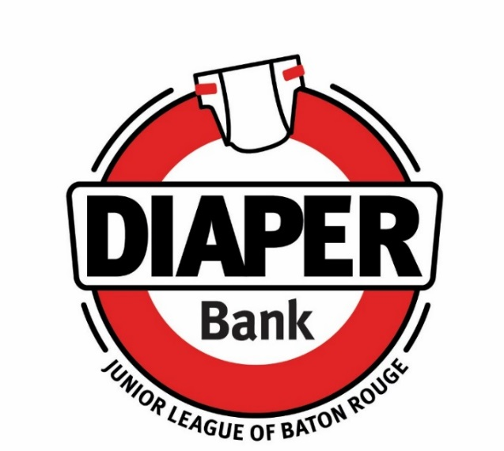

PERMANENT BARREL LOCATIONS

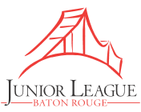  9523 Fenway Avenue  (225) 924-0296  juniorleaguebr.org | 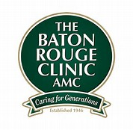  7373 Perkins Road  (225) 769-4044  batonrougeclinic.com | 12351 Industriplex Blvd.  Industriplex @ Airline  (225) 926-4400  batonrougeclinic.com
  37278 Market Place Drive  Prairieville, LA 70769  (225) 744-1717  ptsprairieville.com |   1805 College Drive  (225) 923-3420  mcmainscdc.org |   4271 Perkins Road  (225) 888-5011  olly-olly.com
  Woman’s Center for Wellness  9637 Jefferson Hwy  Jefferson @ Bluebonnet  (225) 924-8300  womans.org/locations/  womans-center-wellness |   5735 Essen Lane, Suite 100  (225) 217-5586  thelittlegym.com/louisiana-baton-rouge/ |   Our Lady of the Lake  Children’s Health Pediatrics  4242 LA Highway 19  Zachary, LA 70791  (225) 654-6140  ololchildrens.org
 | We take open packs!
Please check each site’s website for hours of operation. If you are interested in becoming a permenant barrel location, please email diaperbank@juniorleaguebr.org
Updated 6/2024

