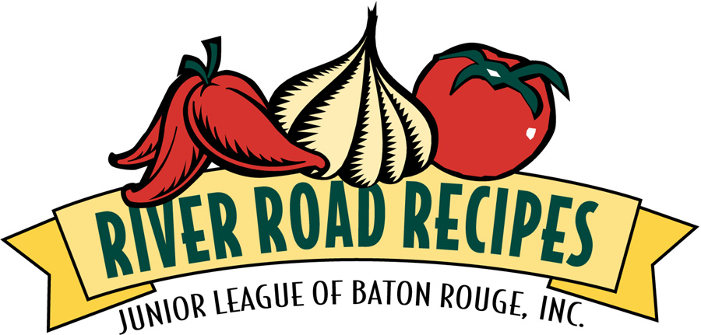

The River Road, from Baton Rouge along the Mississippi River to New Orleans, is a region famous for its culinary history. The best way to sample that tradition is through the River Road Recipes Series from the Junior League of Baton Rouge. Our family of cookbooks is the country’s best-selling community cookbook series.

To order, fill in the information below and return with payment, or phone 1-225-924-0298
Name _________________________________________________________________
Address ________________________________________________________________
City __________________________________ State _________ Zip _____________
12-299 Copies:
River Road Recipes, The Textbook of Louisiana Cuisine ________# @ 11.97 each $ ________
River Road Recipes II, A Second Helping ________# @ 11.97 each $ ________
River Road Recipes III, A Healthy Collection ________# @ 11.97 each $ ________
River Road Recipes IV, Warm Welcomes ________# @ 17.37 each $ ________
300 + Copies:

River Road Recipes, The Textbook of Louisiana Cuisine ________# @ 8.26 each $________
River Road Recipes II, A Second Helping ________# @ 8.26 each $________
River Road Recipes III, A Healthy Collection ________# @ 8.62 each $________
River Road Recipes IV, Warm Welcomes ________# @ 15.62 each $________
Shipping and Handling will be added $________
Louisiana residents add 9% sales tax unless W number is provided. $________
W#: _______________________________________ TOTAL$________
Charge To: VISA ______ MASTERCARD ______
Account No._____________________________ Exp. __________ CVV2 No. ______
Signature ____________________________________ Date: _________________
Mail to: River Road Recipes
Junior League of BR, Inc. ● 9523 Fenway Avenue ● Baton Rouge, LA 70809
225-924-0298 ● juniorleaguebr.com
Proceeds are used for the charitable activities of the Junior League of Baton Rouge, Inc.

